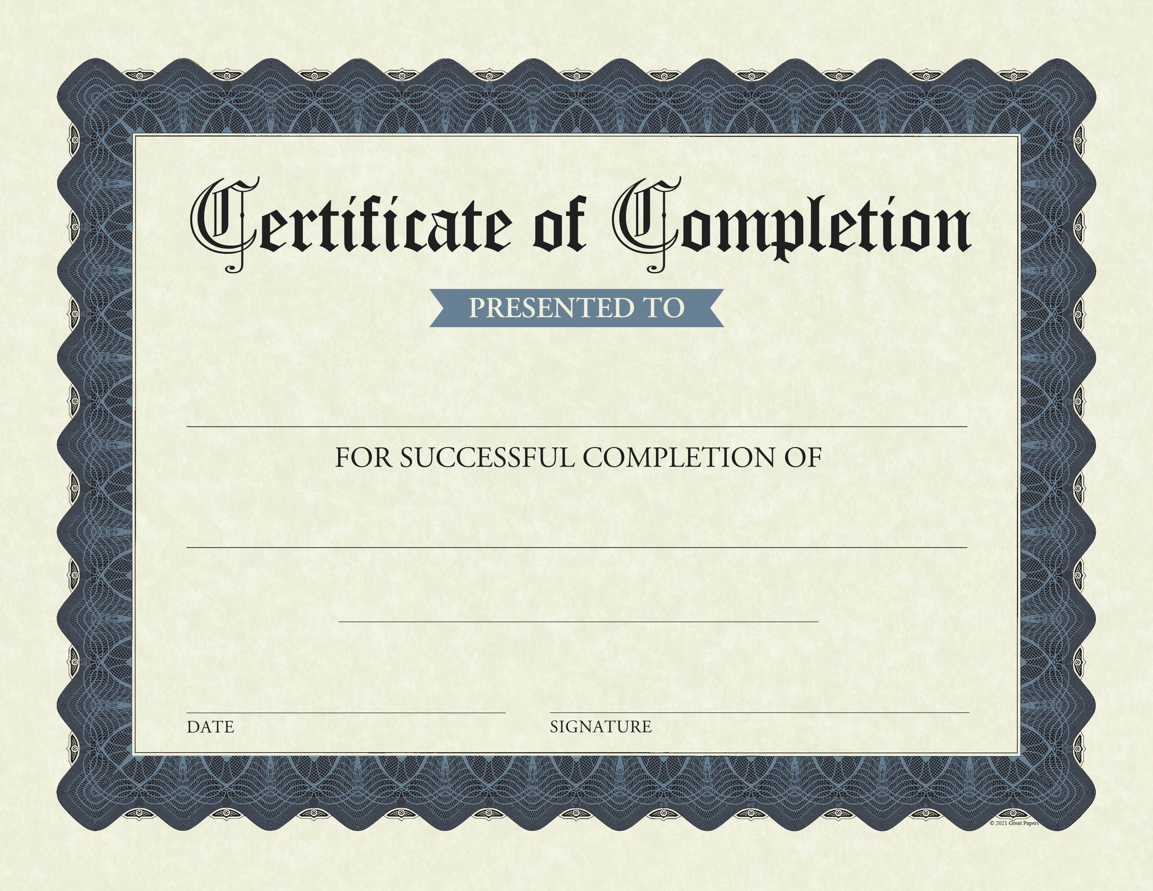

PAUL NICHOLSON
Program of New York
The Probate and Estate Planning

August 12, 2022

